Brandon Hough

CPEN 3710

LQF316

Lab Exercise #7&8

Output when running sortArrays.asm

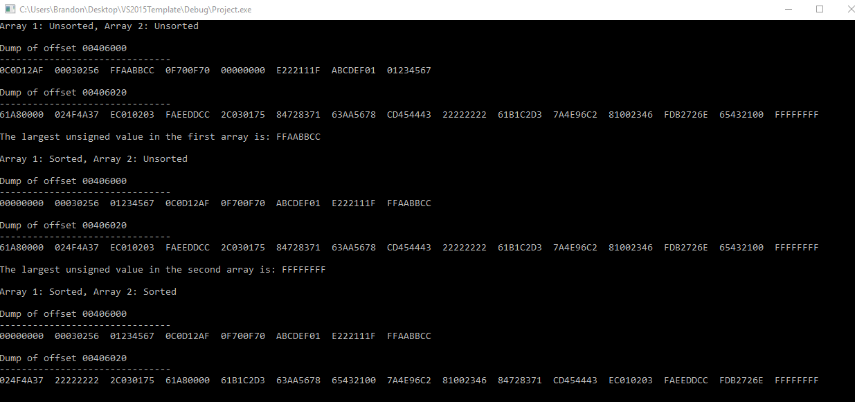

Signed Sheet:

Student’s Name: _______________________________________________

Instructor’s signature for flowchart approval: _________________________

(due before 3:00 p.m. 10/30/2018)

Instructor’s signature for demonstration of working program: ____________

(due before 3:00 p.m. 11/6/2018)